**Chapter 1**

**Functions and Graphs**

**1.4 Inverse Functions**

**Section Exercises**

**For the following exercises, use the horizontal line test to determine whether each of the given graphs is one-to-one.**

183.

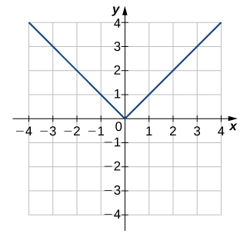

Answer: Not one-to-one

185.

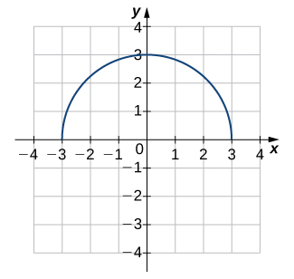

Answer: Not one-to-one

187.

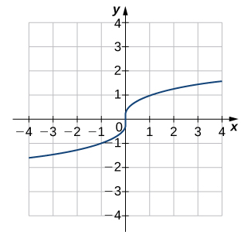

Answer: One-to-one

**For the following exercises, a. find the inverse function, and b. find the domain and range of the inverse function.**

189. 

Answer: a.  b. Domain

191. 

Answer: a.  b. Domain: all real numbers, range: all real numbers

193. 

Answer: a.  b. Domain: , range: 

**For the following exercises, use the graph of  to sketch the graph of its inverse function.**

195.

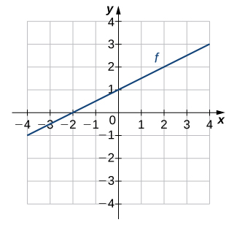

Answer:

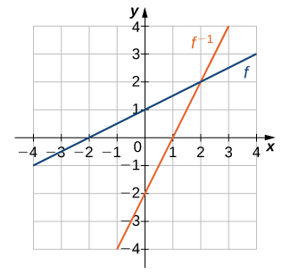

197.

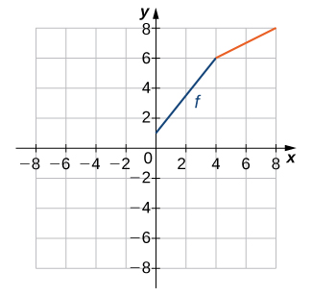

Answer:

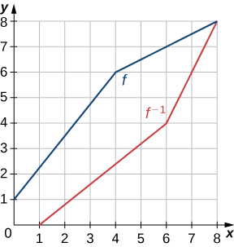

**For the following exercises, use composition to determine which pairs of functions are inverses.**

199. 

Answer: These are inverses.

201. 

Answer: These are not inverses.

203. 

Answer: These are inverses.

205. ,

Answer: These are inverses.

**For the following exercises, evaluate the functions. Give the exact value.**

207. 

Answer: 

209. 

Answer: 

211. 

Answer: 

213. 

Answer: 

215. 

Answer: 

217. **[T]** The velocity *V* (in centimeters per second) of blood in an artery at a distance *x* cm from the center of the artery can be modeled by the function  for .

1. Find .
2. Interpret what the inverse function is used for.
3. Find the distance from the center of an artery with a velocity of 15 cm/sec, 10 cm/sec, and 5 cm/sec.

Answer: a.  b. The inverse function determines the distance from the center of the artery at which blood is flowing with velocity *V*. c. 0.1 cm; 0.14 cm; 0.17 cm

219. **[T]** The cost to remove a toxin from a lake is modeled by the function  where  is the cost (in thousands of dollars) and  is the amount of toxin in a small lake (measured in parts per billion [ppb]). This model is valid only when the amount of toxin is less than 85 ppb.

1. Find the cost to remove 25 ppb, 40 ppb, and 50 ppb of the toxin from the lake.
2. Find the inverse function. c. Use part b. to determine how much of the toxin is removed for $50,000.

Answer: a. $31,250, $66,667, $107,143] b.  c. 34 ppb

221. **[T]** An airplane’s Mach number *M* is the ratio of its speed to the speed of sound. When a plane is flying at a constant altitude, then its Mach angle is given by 

Find the Mach angle (to the nearest degree) for the following Mach numbers.

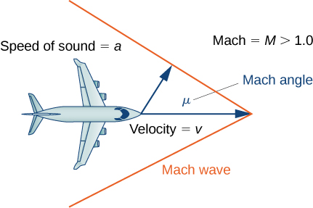

1. 
2. 
3. 

Answer: a.  b.  c. 

223. **[T]** The temperature (in degrees Celsius) of a city in the northern United States can be modeled by the function



where  is time in months and  corresponds to January 1. Determine the month and day when the temperature is .

Answer:  so, the temperature occurs on June 21 and August 15

225. **[T]** An object moving in simple harmonic motion is modeled by the function

,

where  is measured in inches and  is measured in seconds. Determine the first time when the distance moved is 4.5 in.

Answer:  sec

227. **[T]** Use a calculator to evaluate and  Explain the results of each.

Answer: ; the expression does not equal 2.1 since  —in other words, it is not in the restricted domain of   since 2.1 is in the restricted domain of 

**Student Project**

**The Maximum Value of a Function**

1. Consider the graph below of the function  Describe its overall shape. Is it periodic? How do you know?

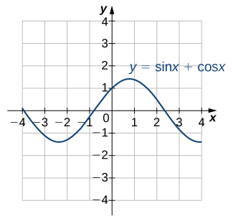

Using a graphing calculator or other graphing device, estimate the - and **-values of the maximum point for the graph (the first such point where *x* > 0). It may be helpful to express the -value as a multiple of π.

Answer: The graph appears to be periodic. Since  and  are periodic functions, we know that the sum of those functions will also be periodic. Using a graphing calculator, we see that the first maximum point of the graph where  is .

3. Repeat for *A* = 1, *B* = 2. Is there any relationship to what you found in part (2)?

Answer:



The first maximum point for  is . The maximum point for  is symmetric about the line  with the maximum point for . and the -value is symmetric about the line .

5. Try to figure out the formula for the **-values.

Answer: 

7. If you found formulas for parts (5) and (6), show that they work together. That is, substitute the -value formula you found into  and simplify it to arrive at the **-value formula you found.

Answer:



This file is copyright 2016, Rice University. All Rights Reserved.